
SCHOOL OF COMPUTING AND ENGINEERING SCIENCES (SCES)
BACHELOR OF SCIENCE IN ELECTRICAL AND ELECTRONICS ENGINEERING (BSEEE)
DIGITAL ELECTRONICS 2
LAB 4: CMOS Principles and Characteristics

BY
Name Adm. No. Signature
Esther Wangari Mugambi 145822 ewm
Edward Aribu 142092 EAM
Quincy Mogaka 133594 QM

Lecturer Supervisor
Dr. Victor Rop Jamlick Ntonjira

21st August 2025
Table of Contents
1 CHAPTER ONE: INTRODUCTION 4
1.0 Brief Introduction 4
1.1 Objectives 5
2 CHAPTER TWO: LITERATURE REVIEW 5
2.0 History of CMOS 5
2.1 CMOS working principle 5
2.2 CMOS NAND GATE 6
2.3 CMOS NOR GATE 6
2.4 CMOS Characteristics 7
2.5 CMOS Advantages 8
2.6 CMOS Disadvantages 8
2.7 CMOS application 9
3 CHAPTER THREE: METHODOLOGY 9
3.0 Equipment required 9
3.1 Experimental procedure 9
3.1.1 3 input NOR gate 9
3.1.2 3-input NAND Gate 10
3.1.3 Transfer characteristics 11
3.1.4 Dissipation 12
3.1.5 Quiescent Dissipation 13
4 CHAPTER FOUR: RESULTS AND FINDINGS 13
4.0 Experimental results 13
4.0.1 3 input NOR gate 13
4.0.2 3 – input NAND gate 14
4.0.3 Transfer Characteristics 15
4.0.4 Dissipation 15
4.0.5 Quiescent Dissipation 16
5 CHAPTER FIVE: CONCLUSIONS AND RECOMMENDATIONS 16
6 References 17

List of figures
Figure 1: CMOS 4
Figure 2: Two input NAND gate 6
Figure 3:NAND logic gate truth table 6
Figure 4: Two input NOR gate 7
Figure 5:NOR logic gate truth table 7
Figure 6:3 input NOR gate 9
Figure 7:3 input nor logic 10
Figure 8:3 input NOR logic with 5V 10
Figure 9:3 input NAND gate 11
Figure 10:3 input NAND table 11
Figure 11:inverter transfer characteristics 11
Figure 12:Transfer characteristics table and graph 12
Figure 13:Circuit for dissipation measurement 12
Figure 14:current vs frequency and load capacity table 13

CHAPTER ONE: INTRODUCTION

Brief Introduction
Complementary Metal-Oxide Semiconductor (CMOS) technology has emerged as one of the most widely adopted approaches in integrated circuit (IC) design due to its efficiency and adaptability. It is extensively employed in computer memories, processors, mobile devices, and application-specific integrated circuits. The technology incorporates both P-channel and N-channel semiconductor devices, which together contribute to its dominance in microprocessors, microcontrollers, and memory architectures such as RAM, ROM, and EEPROM.
In IC design, the transistor is regarded as the fundamental component, with the Metal-Oxide-Semiconductor Field-Effect Transistor (MOSFET) serving as a primary example. MOSFETs are typically fabricated through the layering of semiconductor wafers, silicon dioxide, and a conductive material. While traditional designs relied on metal gates, later developments replaced these with polysilicon gates, and in some instances, a combination of both. These configurations are often referred to as Insulated Gate Field-Effect Transistors (IGFETs), owing to the insulating properties of the silicon dioxide layer beneath the gate[1].
A key advantage of CMOS over NMOS and bipolar technologies lies in its reduced power dissipation. Unlike NMOS and bipolar circuits, CMOS circuits exhibit negligible static power consumption, with energy dissipation occurring primarily during switching events. This characteristic permits the integration of a higher density of gates onto a single chip, thereby enhancing both performance and energy efficiency. The complementary arrangement of P-channel (PMOS) and N-channel (NMOS) transistors further reinforces the suitability of CMOS as the prevailing semiconductor technology for modern integrated systems.
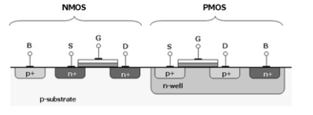
Figure 1: CMOS

Objectives
To work with the complementary symmetry MOS in order to study:
- Logic operations
- Noise immunity
- Dissipation

CHAPTER TWO: LITERATURE REVIEW

History of CMOS
In 1963, Frank Wanlass from Fairchild Semiconductor introduced it. At that time, most electronic circuits used NMOS or bipolar types, which used a lot of power. Wanlass designed a new way using both NMOS and PMOS transistors together, which helped save power.

At first, CMOS wasn't used much because it was slower and cost more to make. But as technology got better, people liked CMOS more because it used less power and could handle electrical noise well. By the 1980s, CMOS started replacing older circuit types in many electronic devices. Today, CMOS is the most used technology for making microchips, like those found in computers, phones, cameras, and many other devices.

CMOS working principle
CMOS works by using two transistors, one NMOS and one PMOS, so that only one conducts at a time. They are connected in a way that when one is on, the other is off. This setup determines whether the output is linked to ground (logic 0) or to the supply voltage (logic 1).

When a high voltage (logic 1) is applied to the input, the NMOS turns on and the PMOS turns off, pulling the output down to ground. When the input is low (logic 0), the PMOS turns on and the NMOS turns off, pulling the output up to VDD (the positive supply). This push-pull switching creates high and low output levels with very little power used, only during the brief switching moments. Because of this alternating behavior, CMOS circuits are highly efficient, using almost no power when in a steady state.

CMOS NAND GATE
In the circuit setup, the two NMOS transistors are placed in series between the output and ground. The two PMOS transistors are placed in parallel between the output and the positive power supply (VDD)[2].
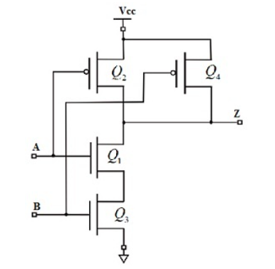
Figure 2: Two input NAND gate
This arrangement controls how the output connects - either to ground or to VDD - based on the input signals. Here's how it works:
- If either A or B is 0, then at least one NMOS transistor is OFF, breaking the ground connection. At the same time, at least one PMOS is ON, allowing current to flow from VDD to the output so the output is 1.
- If both A and B are 1, then both NMOS transistors are ON, connecting the output to ground. Both PMOS transistors are OFF, blocking the path to VDD, so the output becomes 0.
The truth table of the NAND logic gate is given in the table below:
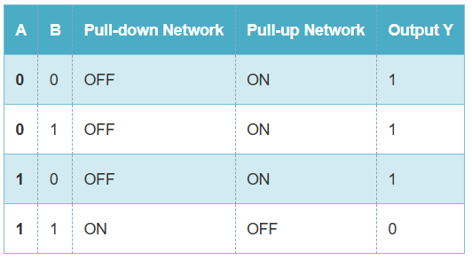
Figure 3:NAND logic gate truth table

CMOS NOR GATE
A 2-input CMOS NOR gate is built using two PMOS transistors in series and two NMOS transistors in parallel. The PMOS transistors connect the output to the power supply (VDD), while the NMOS transistors connect the output to ground.
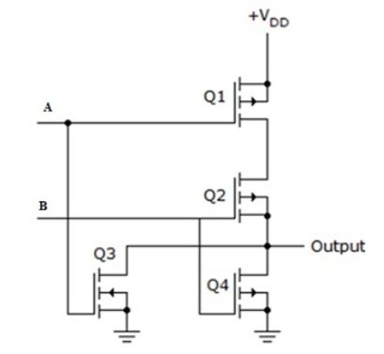
Figure 4: Two input NOR gate
- When both inputs (A and B) are 0, the PMOS transistors are turned on and the NMOS transistors are off. This allows the output to connect to VDD, so the output is high (1).
- If either input is 1, one or both NMOS transistors will turn on and one or both PMOS will turn off. This connects the output to ground, making it low (0).
So, the output is 1 only when both inputs are 0. In all other cases, the output is 0. The truth table is shown below:
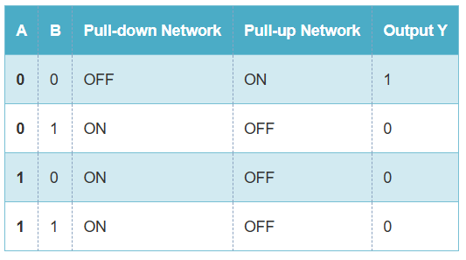
Figure 5:NOR logic gate truth table

CMOS Characteristics
The defining characteristics of Complementary Metal-Oxide Semiconductor (CMOS) technology include low static power consumption and high noise immunity. In CMOS operation, when one transistor within the MOSFET pair is switched off, the series configuration dissipates power only during the transition between states (ON and OFF). This behavior results in minimal static current draw, distinguishing CMOS circuits from other logic families such as Transistor-Transistor Logic (TTL) or NMOS logic, both of which consume standing current even in steady states.
Due to this efficiency, CMOS devices generate significantly less waste heat than their counterparts, enabling the integration of logic functions at much higher densities. This property is central to its widespread adoption in Very-Large-Scale Integration (VLSI) technology, where CMOS has become the dominant fabrication approach for high-performance integrated circuits.
The term MOS derives from the physical structure of the MOSFET, where the gate electrode is positioned atop an oxide insulator over the semiconductor substrate. While early implementations employed aluminum for the gate material, advancements in design replaced this with polysilicon, which offered improved compatibility with scaling processes. More recently, metal gates have been reintroduced in conjunction with high-κ dielectric materials to further enhance transistor performance and overcome limitations in conventional polysilicon gate structures.

CMOS Advantages
The advantages of Complementary Metal-Oxide Semiconductor (CMOS) technology are numerous and have contributed to its dominance over alternative logic families such as Transistor-Transistor Logic (TTL). A key distinction lies in its high noise margin and low power consumption, which result from the absence of a direct conduction path between the power supply (VDD) and ground (GND). Consequently, CMOS devices exhibit negligible power dissipation when held in a steady state, making them both efficient and cost-effective. Signal transmission through CMOS circuits is therefore reliable and economical, particularly in comparison to TTL logic.
TTL circuits, in contrast, rely on bipolar transistors that operate on direct current (DC) pulses. Multiple transistor-based logic gates are typically integrated within a single IC, but such designs generally dissipate more power and are less efficient in high-density applications.Beyond logic applications, CMOS also plays a crucial role in computer architecture, where it is used to describe the memory component of a motherboard that stores BIOS settings, including system time, date, and hardware configuration.
The general advantages of CMOS logic circuits can be summarized as follows:
- Operation with a single power supply (e.g., +VDD)
- Simplicity of design and compact implementation
- High input impedance and large logic voltage swing (up to VDD)
- Negligible static power dissipation
- High fan-out capability and TTL compatibility
- Good noise immunity and stable performance across temperature variations
- Mechanical robustness and reliable operation in diverse conditions
These combined properties make CMOS highly suitable for large-scale digital integration, where efficiency, scalability, and stability are critical design requirements.

CMOS Disadvantages
The disadvantages of CMOS include the following:
- The cost will be increased once the processing steps increases, however, it can be resolved.
- The packing density of CMOS is low as compared with NMOS.
- MOS chips should be secured from getting static charges by placing the leads shorted otherwise; the static charges obtained within leads will damage the chip. This problem can be solved by including protective circuits otherwise devices.
- Another drawback of the CMOS inverter is that it utilizes two transistors as opposed to one NMOS to build an inverter, which means that the CMOS uses more space over the chip as compared with the NMOS. These drawbacks are small due to the progress within the CMOS technology.

CMOS application
CMOS has been used for the following digital IC designs:
- Computer memories, CPU’s
- Microprocessors design
- Flash memory chip design
- Used to design application-specific integrated circuits (ASICs)

CHAPTER THREE: METHODOLOGY

Equipment required
- IC type 4007 dual complementary pair plus inverter
- Potentiometer, 500 ohms, 3 turns 5W
- Dc power supply, 0 - +15 V, regulated at 50mA
- CRO, dc coupled and calibrated
- Pulse generator-variable amplitude positive-going, 0 - +15V, 1 to 10 kHz
- Capacitors, 4700pF, 100 or 200 V
- Dc milliammeter, 1 mA
- Dc microammeter, 100 microamp

Experimental procedure

3 input NOR gate
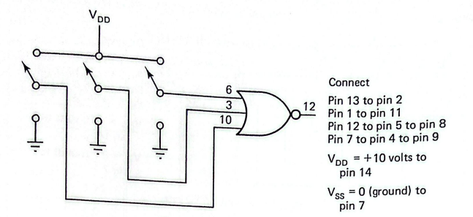
Figure 6:3 input NOR gate
- Apply voltages to the pins indicated and measure the voltage at pin 12 to complete the table bellow
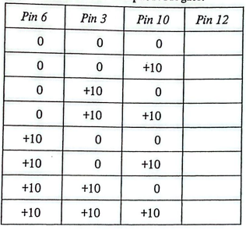
Figure 7:3 input nor logic

- Repeat the data of part a in the table bellow with Vdd = +5
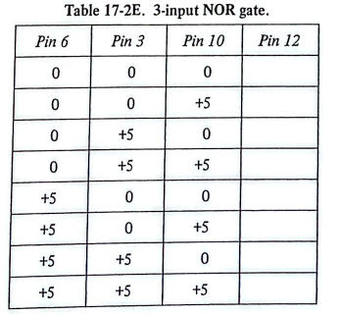
Figure 8:3 input NOR logic with 5V

3-input NAND Gate
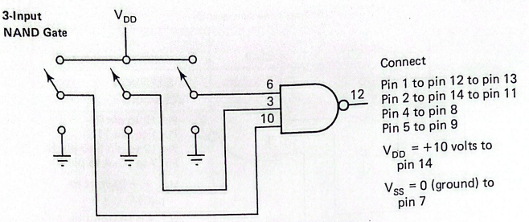
Figure 9:3 input NAND gate
- Apply voltages to the pins indicated and measure the voltage at pin 12 to complete the table bellow
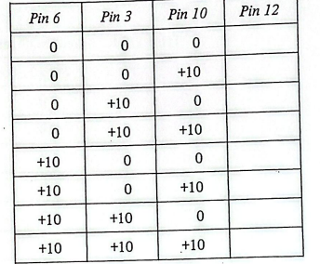
Figure 10:3 input NAND table

Transfer characteristics
The IC will be connected as a triple inverter and the transfer characteristics measured for one of the inverter sections, the pin 6 input, pin 8 output section
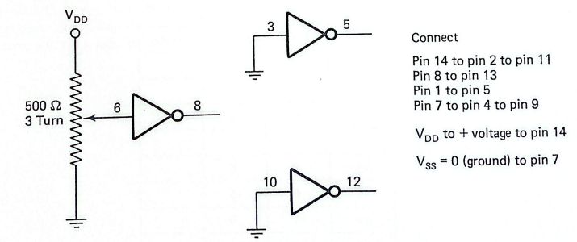
Figure 11:inverter transfer characteristics
- Measure the voltages at pin 6 and pin 8 for each value of Vdd to complete the table below. Plot the data on the curve sheet bellow
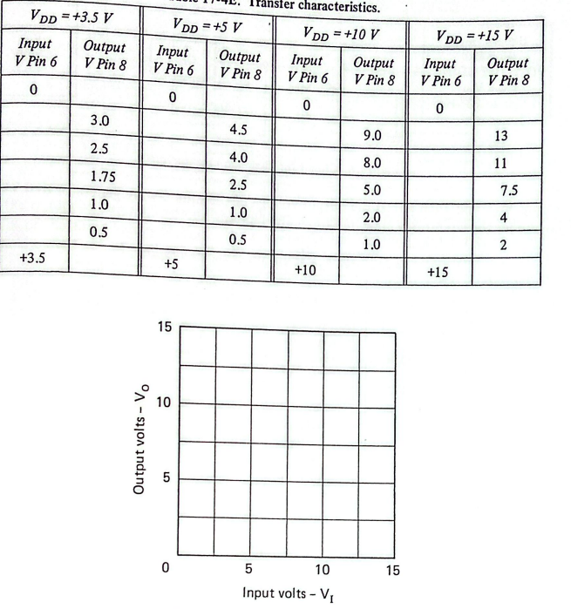
Figure 12:Transfer characteristics table and graph

Dissipation
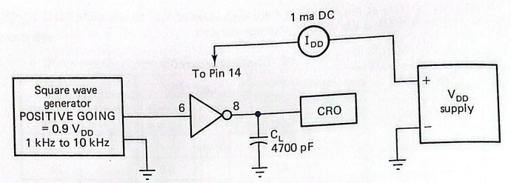
Figure 13:Circuit for dissipation measurement
- Apply Vdd and then adjust the output voltage of the square-wave generator to 0.9Vdd. Measure the Idd under the conditions indicated to complete the table below.
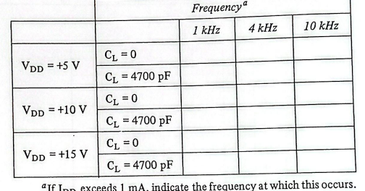
Figure 14:current vs frequency and load capacity table

Quiescent Dissipation
Disconnect the square-wave generator from pin 6.
- Ground pins 6, 3 and 10. Measure Idd. If Idd is too small, change the Idd meter to 100 microamps meter. Idd = ___________
- Connect pins 6, 3 and 10 to Vdd. Measure Idd. Idd = ___________

CHAPTER FOUR: RESULTS AND FINDINGS

Experimental results

3 input NOR gate

Pin 6 | Pin 3 | Pin 10 | Pin 12
0 | 0 | 0 | 9.6
0 | 0 | +10 | 0
0 | +10 | 0 | 0
0 | +10 | +10 | 0
+10 | 0 | 0 | 0
+10 | 0 | +10 | 0
+10 | +10 | 0 | 0
+10 | +10 | +10 | 0
Table 1:3 input NOR gate
Vdd = +5
Pin 6 | Pin 3 | Pin 10 | Pin 12
0 | 0 | 0 | 4.7
0 | 0 | +10 | 0
0 | +10 | 0 | 0
0 | +10 | +10 | 0
+10 | 0 | 0 | 0
+10 | 0 | +10 | 0
+10 | +10 | 0 | 0
+10 | +10 | +10 | 0
Table 2:3 input nor gate with 5 V

3 – input NAND gate

Pin 6 | Pin 3 | Pin 10 | Pin 12
0 | 0 | 0 | 9.8V
0 | 0 | +10 | 9.8
0 | +10 | 0 | 9.8
0 | +10 | +10 | 9.8
+10 | 0 | 0 | 9.8
+10 | 0 | +10 | 9.8
+10 | +10 | 0 | 9.8
+10 | +10 | +10 | 0
Table 3: 3 input NAND gate

Transfer Characteristics

V_{DD} = +3.5V |  | V_{DD} = +5V |  | V_{DD} = +10V |  | V_{DD} = +15V
Input  V Pin 6 | Output  V Pin 8 | Input  V Pin 6 | Output  V Pin 8 | Input  V Pin 6 | Output  V Pin 8 | Input  V Pin 6 | Output  V Pin 8
0 | 3.3 | 0 | 4.7 | 0 | 9.8 | 0 | 14.8
0 | 3.0 | 0 | 4.5 | 0 | 9.0 | 0 | 13
0.5 | 2.5 | 0 | 4.0 | 0 | 8.0 | 0.4 | 11
3.0 | 1.75 | 3.7 | 2.5 | 4.2 | 5.0 | 6.0 | 7.5
3.2 | 1.0 | 4.7 | 1.0 | 9.7 | 2.0 | 14 | 4
3.3 | 0.5 | 4.7 | 0.5 | 9.7 | 1.0 | 14.7 | 2
+3.5 | 0 | +5 | 0 | +10 | 0 | +15 | 0
Table 4:Transfer characteristics

Dissipation
 | Frequency
 |  | 1kHz | 4 kHz | 10kHz
V_{DD} = +5V | C_{L} = 0 | 0.75 | 0.79 | 0.84
 | C_{L} = 4700 pF | 0.70 | 0.73 | 0.71
V_{DD} = +10V | C_{L} = 0 | 2.30 | 2.08 | 2.26
 | C_{L} = 4700 pF | 2.22 | 2.05 | 2.16
V_{DD} = +15V | C_{L} = 0 | 2.95 | 2.68 | 3.23
 | C_{L} = 4700 pF | 2.86 | 2.98 | 2.95
Table 5:Dissipation table

Quiescent Dissipation
I_{DD} =
I_{DD} =

CHAPTER FIVE: CONCLUSIONS AND RECOMMENDATIONS

Conclusions
From the experiments conducted, the following conclusions were made:
Logic Gate Operation – The results from the 3-input NOR and NAND gates confirmed the expected truth tables, validating the correct operation of CMOS logic circuits.
Transfer Characteristics – The measured input-output characteristics of the CMOS inverter showed sharp transitions, demonstrating high noise immunity and confirming the strong switching capability of CMOS devices.
Power Dissipation – CMOS circuits exhibited very low static power consumption, with dissipation occurring primarily during switching events. The dissipation values increased with higher supply voltages and frequency, which aligns with CMOS theoretical principles.
Quiescent Current – The quiescent dissipation measurements indicated negligible current draw when the circuit was in a steady state, affirming one of CMOS’s major advantages over other logic families.
Overall Findings – The experiments verified that CMOS technology provides reliable logic implementation, high efficiency, and low power consumption, making it highly suitable for large-scale integration in modern electronics.

Recommendations
Based on the experiment and observations, the following recommendations are proposed:
Improved Measurement Accuracy – Future experiments should employ more precise digital measuring instruments to minimize error in voltage and current readings.
Extended Frequency Range – Testing the circuits at higher frequencies would provide deeper insight into the switching speed and limitations of CMOS devices.
Device Protection – Since CMOS devices are highly sensitive to static charges, proper handling and use of antistatic equipment should always be observed in practical sessions.
Further Study – Additional experiments on CMOS-based sequential circuits (e.g., flip-flops and counters) are recommended to expand understanding beyond combinational logic.
Applications Focus – Linking practical experiments with real-world applications such as microprocessors, memories, and ASICs would strengthen the connection between theory and practice.

References

‌

‌

